User Guide for T24 User Creations
Document Requirement to Grant T24 User Access
- For New User
1. The user must attach Access Request form on which every necessary field must be properly filled and the access requester and the manager must sign at requested by and approved by field respectively. And also they must use their own Branch’s stamp.
2.The must attach his/her visible Employment letter
3. .The user must attach his/her user delivery form after he received the access for confirmations.
- For Available User Role change
1. The user must attach properly written delegation letter if required
2. The user must attach user access request form properly field as described above.
- For Branch Change
1 The user must attach properly written Transfer Letter by his/her previous branch
2The user must properly fill the access request form as described above
3. The user must close his/her TILL in his/her previous both conventional and IFB branches.

- List of all available User Roles and Respective User Groups
- Branch Maker(?3) – For Branch maker
- Branch Supervisor(Checker ?4) – For Branch Checker
- Branch Cashier(?5) – For Branch Cashier
- Branch Supervisor(?7) – For Branch Manager and operation manager
- Auditor(?8) – For Branch Auditor
- Auditor(?9) –For Head Office Auditor
- Finance Senior Officer(?10)
- Check Clearance Office(?11)
- Head Office Cashier(?12)- For Head office Cashier
- Head Office Cashier(?13)
- Head Office Cashier Inputter(?14)
- District Role(15)
- Finance Inputter with ATS(?16)
- Finance Senior Officer with ATS(?17)
- Finance Senior Officer with ATS AUT(?18)
- Head Office KYC(?20) – For Head office KYC user only
- KYC (?21)-For Branch KYC user While the branch is requested and Approved by Head office.
- Digital Banking Inputter(?30)
- Digital Banking Checker(?31)
- Digital Banking Authorizer(?32)
- Branch Maker(?33)- Role for branch maker Selling foreign Exchange and make OD
- Share Management Maker(?36)
- Share Management Authorizer(?37)
- Reports (?40)
- Credit Risk Monitoring(?41)
- Risk Compliance Monitoring(?42)
- Branch Maker for Currency Exchange(?43)- Role for branch maker Selling foreign Exchange
- Credit Maker North District Change(?45)- District Credit maker with All make functionality except disbursement
- Credit Checker District Change(?46)- District Credit checker with All check functionality except disbursement
- Credit Maker-Checker Change(?50)- All Functionality except Disbursements
- Credit Maker North District(51) - District Credit maker with All make functionality
- Credit Checker(?52)
- Credit Checker District(?53)- District Credit checker with All check functionality
- Credit Maker-Checker(?54)- All Functionality
- Credit Maker(?55)- Credit Maker with All make functionality
- Credit Checker(?56)- Credit Checker with All check functionality
- Credit Portfolio(?57)- Head office Credit Portfolio
- Credit Maker Change(?58)- Credit Maker with All make functionality except disbursements
- Credit Checker Change(?59)- Credit Checker with All check functionality except disbursements
- Head Office IFB CRM(?60)
- Head Office IFB Maker(?61)
- Head Office IFB Checker(?62)
- Branch Supervisor(?77) -Branch Manager Access with OD authorization
- Business Support Operation(?95)
- Branch Maker with Extra Limit (?102) –For Branch maker with Extra Limit if the Branch requested.
- Contact Center(?205)

User application fields
- The USER NAME contains the full name of the user.
- The SIGN ON NAME will be used to sign into T24. Again, this has to be different from the ID.(Sign On Name – First letter of Full name and Id . for example –HZA000110)
- CLASSIFICATION can be internal or external. Internal indicates that the User is an employee of the bank using T24.
- The LANGUAGE selected in the language field will indicate the language of objects like user messages, instructions and help text. If no selection is made, then English will default
As Shown below below in the Image.
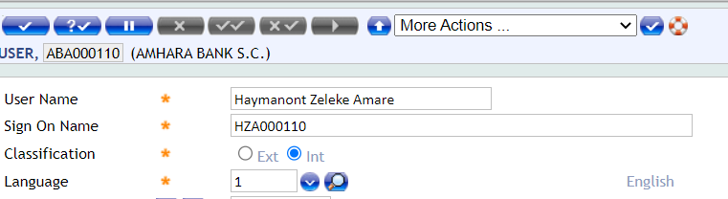

- T24 allows the user to access multiple companies as it supports MULTI COMPANY set up.
- COMPANY CODE specifies the companies to which the user has access. The first company code specified here will be the default company to which the user will be logged into.
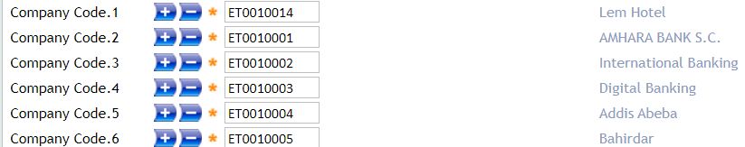

i.e. Haymanote Zelke Asmare found in Lem Hotel.

- DEPARTMENT CODE specifies the department to which the user belongs.
See below image.
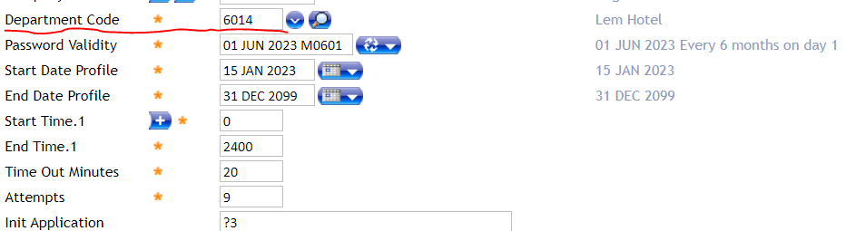
- The PASSWORD VALIDITY field specifies the next date on which the User must change his Password and the subsequent frequency of change after that.
- The START DATE PROFILE is the date from which the profile of the user will be active.
- The END DATE PROFILE is the date until which the user profile is active
- The START TIME is based on the 24 hour clock.
- The END TIME is based on the 24 hour clock as well. Irrespective of the time specified here, if the user is logged in to the system, he will be allowed to continue accessing T24.
As shown below in the image.
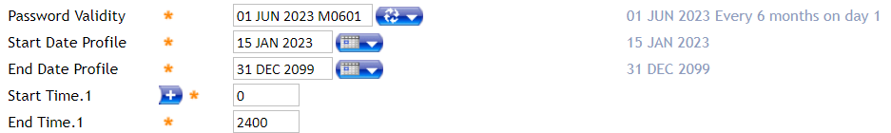
- The TIME OUT MINUTES field specifies the maximum time in minutes during which the User may be inactive without being Signed Off automatically.
- The ATTEMPTS field allows only one numeric character for input. The maximum number of attempts that can be set is 9.
As shown below in the image.
- The INIT APPLICATION field is used to assign a specific Menu to a User. This is the Menu the User will see when he signs on to T24.
Identify User role or check which role is requested from Branch(Maker(?3), Checker(?4), Cash Supervisor(?5) , Branch Manager(?7) Or Internal Auditor for branch(?8) .

See below Image

- The COMPANY RESTRICTION field contains a valid company code. This is used to specify a Company in which we want to set access rights for a User.
- The APPLICATION field can contain a valid application name which the User can access. ALL.PG implies that the user will have access to all applications in T24 in the company specified in the field COMPANY RESTRICTION
- The FUNCTION field is where we list the valid functions that the user can perform in this Company. See Sample Give Function.
- Maker(?3) - B C D E F H I L P R S V
- Checker(?4) - A 2 B C D E F H I L P R S V Q
- Cash Supervisor(?5) - A 2 B C D E F H I L P R S V
- Branch Manager(?7) - A 2 B C D E F H I L P R S V
- Branch Auditor(?8)- B C D E F H I L P R S V Q
- ?9 Head Office Auditor -C B E F H L P S
- ?10 finance Checker -A 2 B C D E F H I L P R S V
- ?13 Finance Maker-B C D E F H I L P R S V
- ?20 KYC-A 2 B C D E F H I L P R S V
- ?30 Digital Maker-B C D E F H I L P R S V
- ?32 Digital Checker-A 2 B C D E F H I L P R S V
- ?57 Credit Portfolio-B C D E F H I L P R S V
- ?58 Credit Maker -B C D E F H I L P R S V
- ?59 Credit Checker- A 2 B C D E F H I L P R S V
- ?50 Credit Maker-Checker B C D E F H I L P R S V
- ?45 Credit Maker for District- B C D E F H I L P R S V
- ?46 Credit Checker for District- A 2 B C D E F H I L P R S V
See Sample image
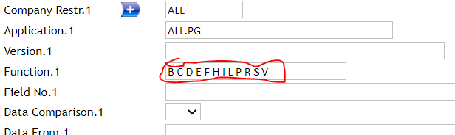
- Override Class.-Authorization Transaction Level
- Maker role – level 1
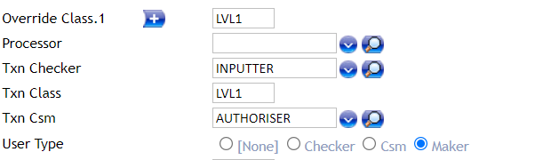

- Checker Role: Level 2 and level 3
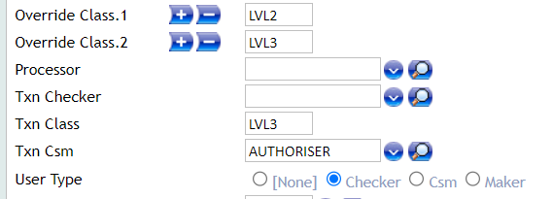
- Cash Supervisor: level 2 and Level 3
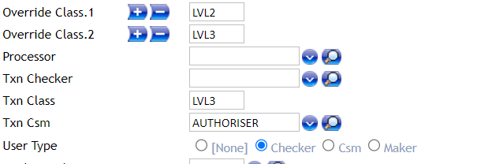
- Branch manager: Level 2, level 3 and Level 4
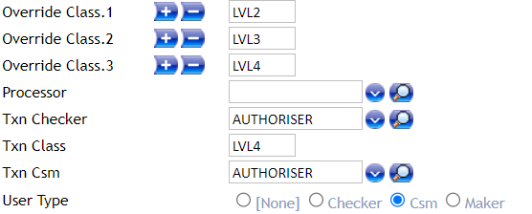

Necessary Steps to Grant Access for Users
- If the user is new user, copy the record of other user that has similar roles and in the same branch. Paste it to new user records and amend username, sign on name and start of date and keep the rest as it is.
As shown in below screen shoot.
For example to create a new maker user in Arat kilo branch
Find by inti application/user role and department code/account officer.

- Menu Navigation:
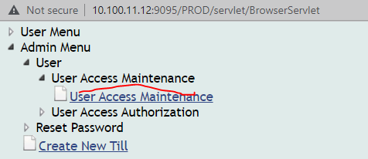
Then Click User Access Maintenance Link
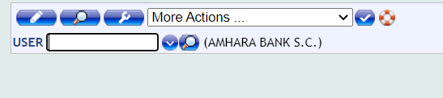

- Search the Requested Role and Click find Button
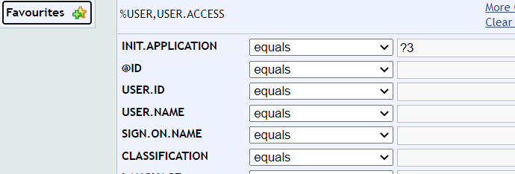

Copy the record
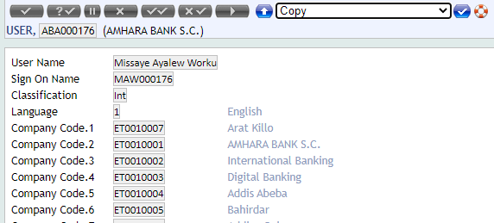
Enter new user id and paste on it the already copied record.

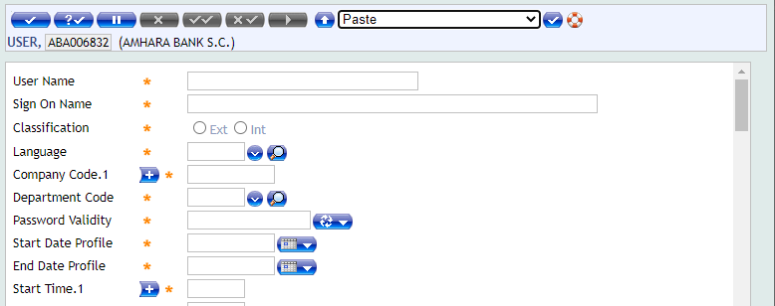

Change user full name in user name field and write sign on name in sign on name field, make start of date today and keep the rest as is it finally validate and commit.
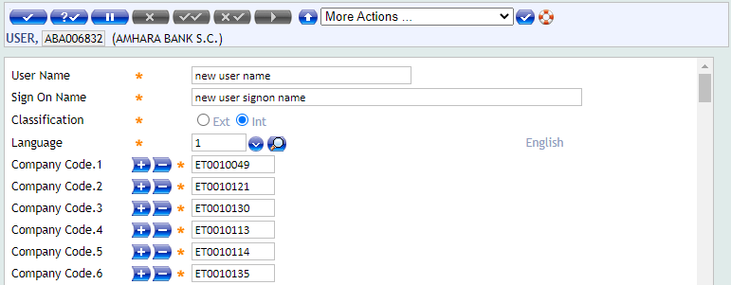

- If the user is available user or requested role change you can amend it according to the role he/she requested.
As shown in the below screen shoot:
If the user is request to role change to maker role, amend only the fields as shown below.

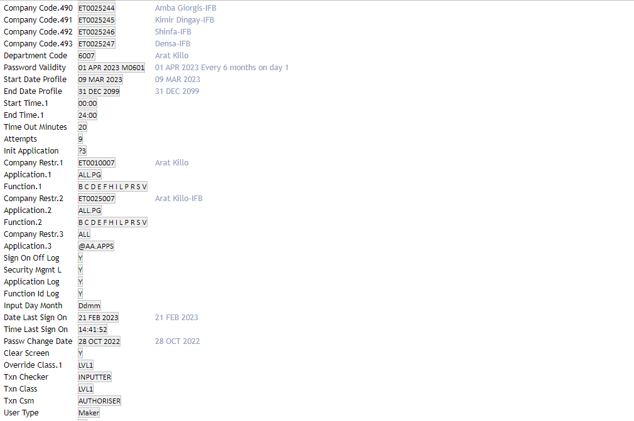
If the user is request to role change to Checker role, amend only the fields as shown below.
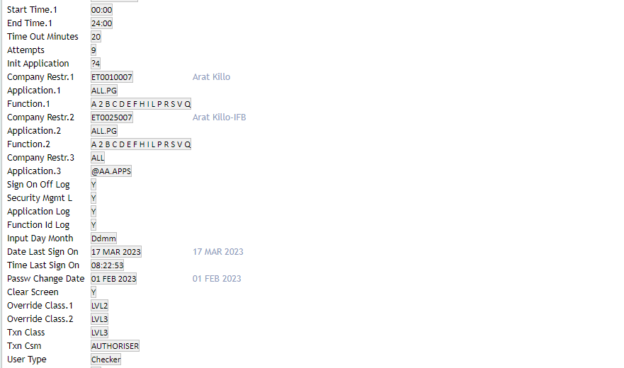
If the user is request to role change to Casher role, amend only the fields as shown below.
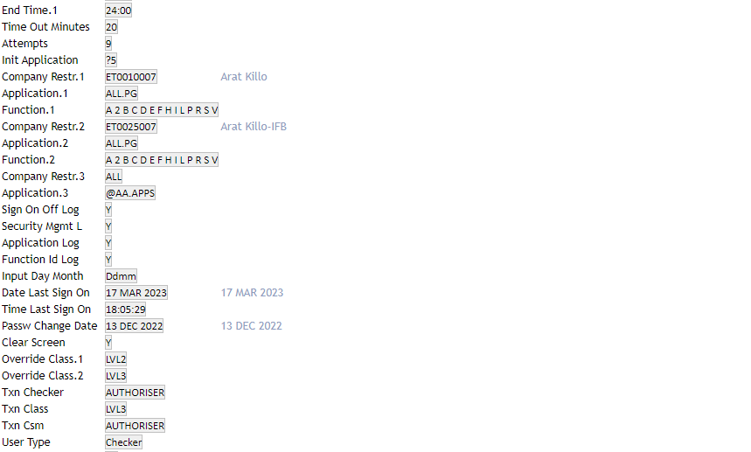

If the user is request to role change to manager or operation manager role, amend only the fields as shown below.
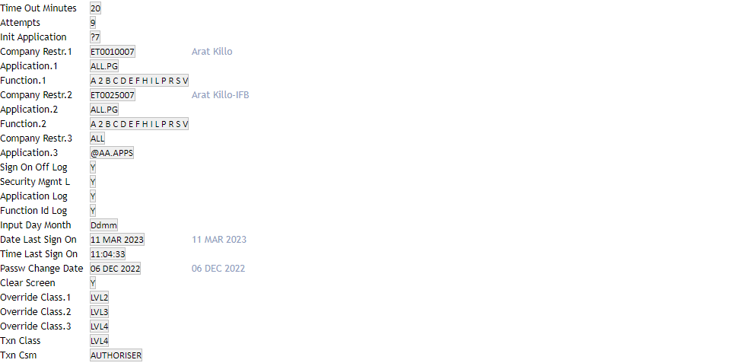
- If the user is requested branch change you must amend the first company, department code and the company restriction 1 and company restriction 2 according to his/her branch.
As shown in the below screen shoot:
For example if the user is request to branch change from Arat kilo to Addis Abeba branch with the same role.
Amend the below highlighted fields as shown below.
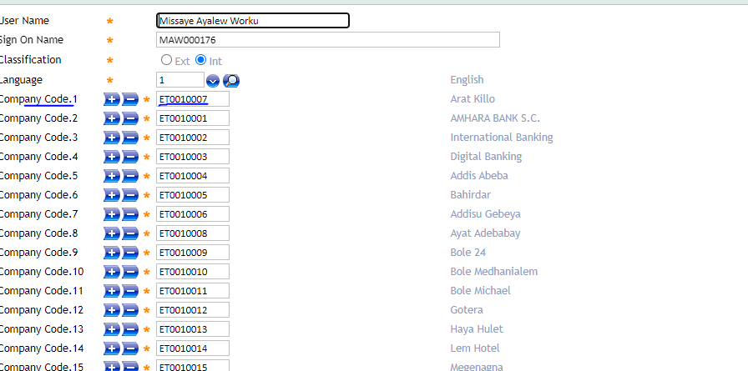

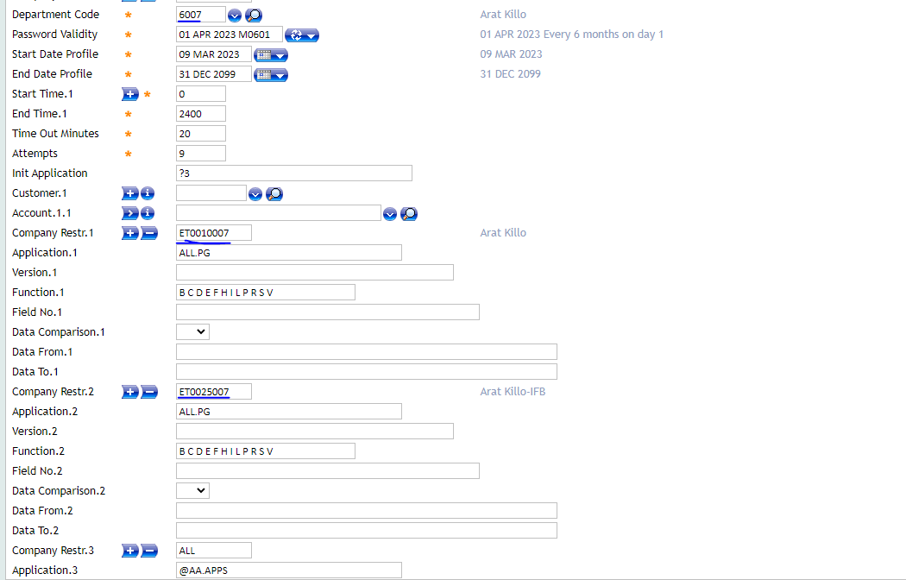

- After finishing User Access Creation, Authorize By another User.
- Menu Navigation
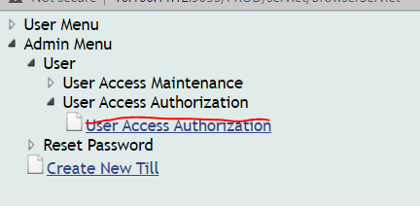

Then, Click User Access Authorization.

Then Click Authorize Button.
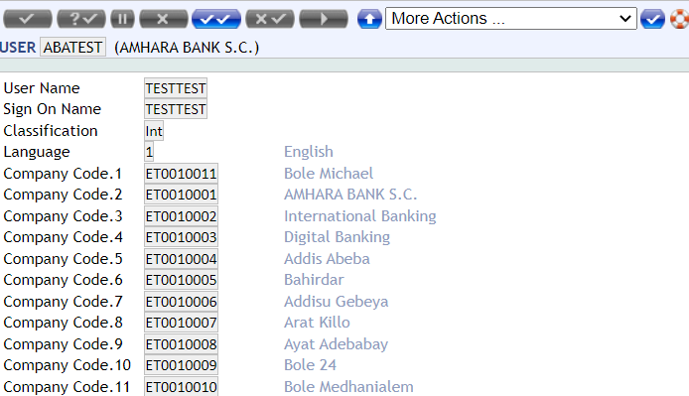

Teller Id
- A Teller can perform transactions only if their till is open.
- The Head Teller opens a till for every teller and then closes the till, which is usually performed at the close of the day. The balance in the till is updated with every cash transaction.
- For a teller to perform transactions on a till, the till must be opened and assigned to the teller.
- A user cannot be assigned to more than one open till at any time, unless special arrangements are made for multi tills. If necessary, a new user can be assigned to the existing till by changing the user ID of that till. After the change, the new user can operate using that till.
- The status is neither open nor close and has a null value. All other tills are to be opened before commencing daily teller operations and closed once the operations are completed.
Teller Id Creation Process
- Teller id created only for maker and Cash Supervisor Role.
- When you create Till id , you must found or switched on his/her branch by Tools
- If the user is available, it must be closed in pervious branch before created new Till.
- Teller Id maximum 4 digit
- User Id of User allotted to till.
- Menu Navigation
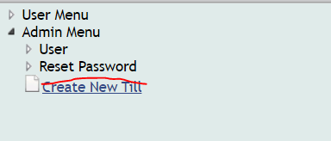
As shown below the image
- Then Click Create New Till link.
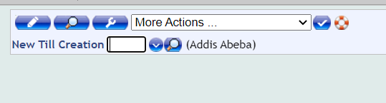
- Use 4 Digit Till number of your Choice
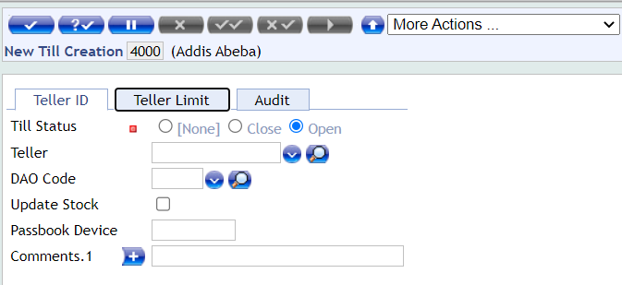
- Assign this Till Id to User ID and Validate it
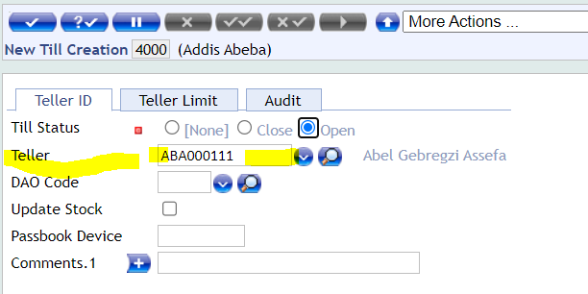
- After that commit it .The Till automatically authorized

Password Reset
- The user must attach Access Request form on which necessary field(Password reset section) must be properly filled and the access requester and the manager must sign at requested by and approved by field respectively. And also they must use their own Branch’s stamp.
Password Reset Process
- Menu Navigations
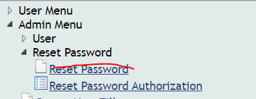

- Click Reset Password Link.
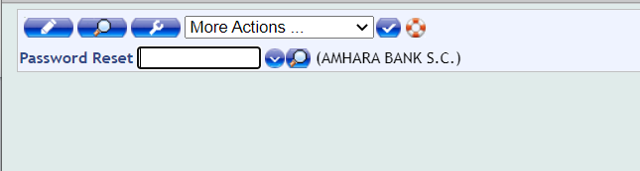
- Enter Password reset user Id
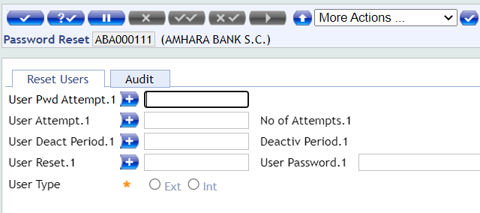
- Fill User Reset and User Password Filled
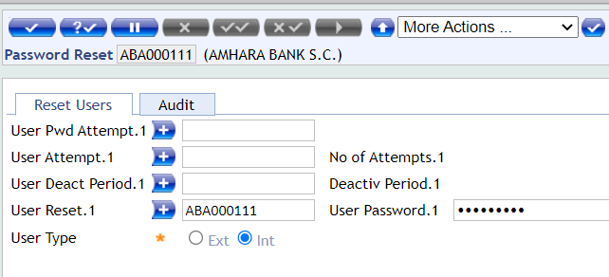
- After that commit it.
- Then Authorize by Another User.
Menu Navigation
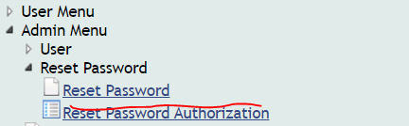

Disabling User Access/Reversal

When you disable user access, Check necessary document like releases letter.
- Type USER application in Command line. See screenshot image
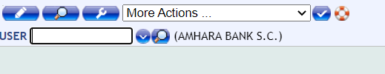
- Enter User Id and Click Perform action an contract
As shown below in the image
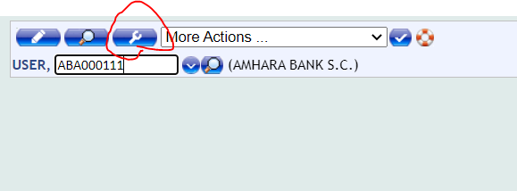
- Then Click reverse button to disable user access.
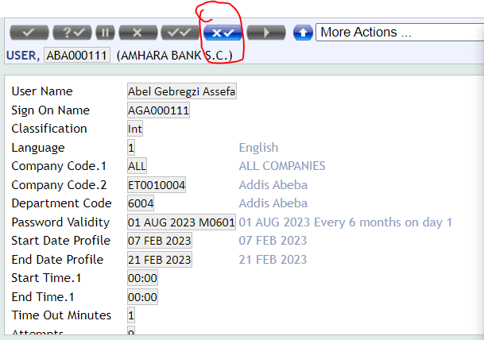

- You will add in addition to This Documentations.

We prepare Menu in the Production for Business Support Team
?95

